### Overview

Tables shown below are part of Husna Homestay company database.

Client

|  |  |  |
| --- | --- | --- |
| clientid (pk) | clientname | contactdetails |
| Client1 | Suriyani Sahar | 0195656565 |
| Client2 | Rozie | 0127778888 |
| Client3 | Muaz | muaz@gmail.com |

Apartment

|  |  |  |
| --- | --- | --- |
| houseno(pk) | housedescription | pernight |
| F104 | Studio Type | 80 |
| F202 | Standard Type | 150 |
| E101 | Standard Type | 130 |

Booking

|  |  |  |  |
| --- | --- | --- | --- |
| clientid (fk) | progid (fk) | checkin | checkout |
| Client1 | F104 | 2022-01-01 | 2022-03-31 |
| Client2 | F202 | 2022-02-01 | 2022-04-30 |
| Client3 | F202 | 2022-05-01 | 2022-07-31 |

### Software requirement: Visual Studio Code

**Part A: Create a Django project (Task 1-3)**

* + 1. Create a django project name ‘yourstudentid’ for example: BCS2107001.
    2. A screen shot of a computer

       Description automatically generatedExecute runserver command.
    3. Create a subproject name Homestay

**Part B: Create database. (Task 4-5)**

* + 1. **A screen shot of a computer

       Description automatically generated**Add application in installed apps setting.
    2. Create class based on the tables provided in overview above with appropriate:

1. Class name
2. Properties (data type, maximum number of character)
3. 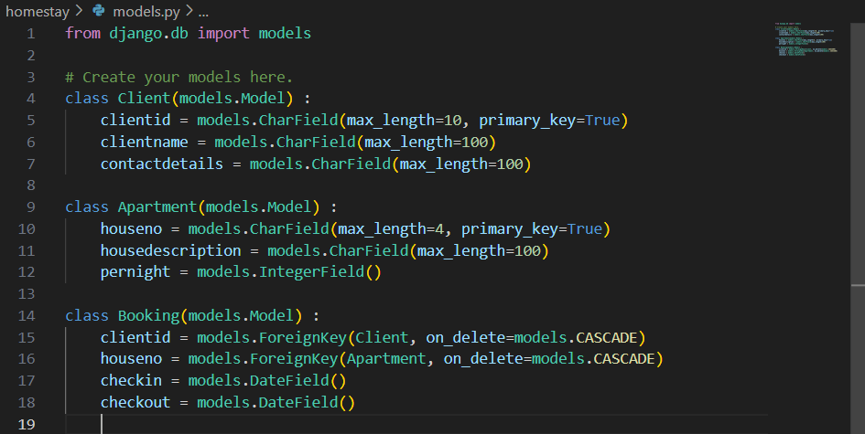Composition/aggregation

**Part C: Create / Update / Read / Delete objects (Task 6-13)**

* + 1. A computer screen with white text

       Description automatically generatedA black background with white text

       Description automatically generatedA screen shot of a computer program

       Description automatically generatedInsert and save data into database.
    2. A computer code with white text

       Description automatically generated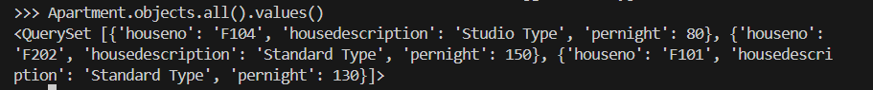A screenshot of a computer

       Description automatically generatedDisplay data for all tables using command prompt.
    3. A screenshot of a computer program

       Description automatically generatedA black and white screen with white text

       Description automatically generatedDisplay all tables and its objects data using Visual Studio Code

* + 1. Terminate interactive console by using command prompt and provide screenshot.
    2. A screen shot of a computer code

       Description automatically generatedAdd new field Status in table Apartment and set default to ‘good’.
    3. A black and white screen with white text

       Description automatically generatedUpdate **contactdetails=0196667777** in table Client for **clientid = Client3.**
    4. A black and white rectangular sign with white text

       Description automatically generatedDelete object in table **Apartment** for **houseno =E101.**
    5. Display data in all tables and its objects after executing all tasks until task 12.